**Supplementary file**

Table of contents

**Supplementary Table 1**. Searching in PubMed

**Supplementary Table 2**. Searching in Ovid-Cochrane

**Supplementary Table 3**. Searching in Ichu-shi

**Supplementary Table 4**. Summary of the study findings

**Supplementary Table 5**. Risk of bias tool assessments among included interventional studies

**Supplementary Figure 1**. PRISMA flow diagram

**Supplementary Figure 2**. Sensitivity analysis after excluding three studies employing the same target blood pressure for both home and office blood pressure

**Supplementary Figure 3.** Sensitivity analysis (with telemonitoring)

**Supplementary Figure 4.** Sensitivity analysis (without telemonitoring)

**Supplementary Figure 5**. Funnel plot for all studies

|  |  |  |
| --- | --- | --- |
| **#** | **Search words** | **N** |
| #1 | ("randomized controlled trial"[Publication Type] OR "controlled clinical trial"[Publication Type] OR "randomized"[Title/Abstract] OR "placebo"[Title/Abstract] OR "clinical trials as topic"[MeSH Terms] OR "randomly"[Title/Abstract] OR "trial"[Title]) NOT ("animals"[MeSH Terms] NOT "humans"[MeSH Terms]) | 1557052 |
| #2 | "blood pressure determination"[MeSH Terms] OR "blood pressure"[MeSH Terms] OR "arterial pressure"[MeSH Terms] OR "blood pressure monitoring, ambulatory"[MeSH Terms] OR "blood pressure monitors"[MeSH Terms] OR "hypertension"[MeSH Terms] OR "essential hypertension"[MeSH Terms] OR "antihypertensive agents"[MeSH Terms] OR "hypertens*"[Title/Abstract] | 823603 |
| #3 | "Home Environment"[MeSH Terms] OR "Interactive Health Communication Applications"[Title/Abstract] OR "self measurement"[Title/Abstract] OR "self monitoring"[Title/Abstract] OR "self-recording"[Title/Abstract] OR "self-performed"[Title/Abstract] OR "home measurement"[Title/Abstract] OR "home intervention"[Title/Abstract] OR "home monitoring"[Title/Abstract] OR "remote monitoring"[Title/Abstract] OR "telecommunicat*"[Title/Abstract] OR "teleconferenc*"[Title/Abstract] OR "teleconsult*"[Title/Abstract] OR "telemonitor*"[Title/Abstract] OR "telehome*"[Title/Abstract] OR "telecare"[Title/Abstract] OR "telehealth*"[Title/Abstract] OR "telemed*"[Title/Abstract] OR "telemetr*"[Title/Abstract] OR "drug therapy, computer assisted"[MeSH Terms] OR "therapy, computer assisted"[MeSH Terms] OR "Internet"[MeSH Terms] OR "Computers"[MeSH Terms] OR "home care services, hospital based"[MeSH Terms] OR "Home Care Services"[MeSH Terms] OR "Remote Consultation"[MeSH Terms] OR "Telemetry"[MeSH Terms] OR "monitoring, ambulatory"[MeSH Terms] OR "Telecommunications"[MeSH Terms] OR "Telemedicine"[MeSH Terms] | 454251 |
| #4 | #1 and #2 and #3 | 3805 |

**Supplementary Table 1.** Searching in PubMed (Search date: March 19, 2024)

**Supplementary Table 2.** Searching in Cochran database (Search date: March 21, 2024)

|  |  |  |
| --- | --- | --- |
| **#** | **Search words** | **N** |
| #1 | ("randomized controlled trial"):pt | 1372719 |
| #2 | ("controlled clinical trial"):pt |
| #3 | (randomized):ti |
| #4 | (randomized):ab |
| #5 | (placebo):ti |
| #6 | (placebo):ab |
| #7 | MeSH descriptor: [Clinical Trials as Topic] this term only |
| #8 | (randomly):ti |
| #9 | (randomly):ab |
| #10 | (trial):ti |
| #11 | #1 or #2 or #3 or #4 or #5 or #6 or #7 or #8 or #9 or #10 |
| #12 | MeSH descriptor: [Animals] this term only |
| #13 | MeSH descriptor: [Humans] this term only |
| #14 | #12 not #13 |
| #15 | #11 not #14 |
| #16 | MeSH descriptor: [Blood Pressure Determination] explode all trees | 93590 |
| #17 | MeSH descriptor: [Blood Pressure] explode all trees |
| #18 | MeSH descriptor: [Arterial Pressure] explode all trees |
| #19 | MeSH descriptor: [Blood Pressure Monitoring, Ambulatory] explode all trees |
| #20 | MeSH descriptor: [Blood Pressure Monitors] explode all trees |
| #21 | MeSH descriptor: [Hypertension] explode all trees |
| #22 | MeSH descriptor: [Essential Hypertension] explode all trees |
| #23 | MeSH descriptor: [Antihypertensive Agents] explode all trees |
| #24 | (hypertens*):ti |
| #25 | (hypertens*):ab |
| #26 | #16 or #17 or #18 or #19 or #20 or #21 or #22 or #23 or #24 or #25 |
| #27 | MeSH descriptor: [Home Environment] explode all trees | 54398 |
| #28 | ("Interactive Health Communication Applications"):ti |
| #29 | ("Interactive Health Communication Applications"):ab |
| #30 | ("self measurement"):ti |
| #31 | ("self measurement"):ab |
| #32 | ("self monitoring"):ti |
| #33 | ("self monitoring"):ab |
| #34 | (self-recording):ti |
| #35 | (self-recording):ab |
| #36 | (self-performed):ti |
| #37 | (self-performed):ab |
| #38 | ("home measurement"):ti |
| #39 | ("home measurement"):ab |
| #40 | ("home monitoring"):ti |
| #41 | ("home monitoring"):ab |
| #42 | ("remote monitoring"):ti |
| #43 | ("remote monitoring"):ab |
| #44 | (telecommunicat*):ti |
| #45 | (telecommunicat*):ab |
| #46 | (teleconferenc*):ti |
| #47 | (teleconferenc*):ab |
| #48 | (teleconsult*):ti |
| #49 | (teleconsult*):ab |
| #50 | (telemonitor*):ti |
| #51 | (telemonitor*):ab |
| #52 | (telehome*):ti |
| #53 | (telehome*):ab |
| #54 | (telecare):ti |
| #55 | (telecare):ab |
| #56 | (telehealth*):ti |
| #57 | (telehealth*):ab |
| #58 | (telemed*):ti |
| #59 | (telemed*):ab |
| #60 | (telemetr*):ti |
| #61 | (telemetr*):ab |
| #62 | MeSH descriptor: [Drug Therapy, Computer-Assisted] explode all trees |
| #63 | MeSH descriptor: [Therapy, Computer-Assisted] explode all trees |
| #64 | MeSH descriptor: [Internet] explode all trees |
| #65 | MeSH descriptor: [Computers] explode all trees |
| #66 | MeSH descriptor: [Home Care Services, Hospital-Based] explode all trees |
| #67 | MeSH descriptor: [Home Care Services] explode all trees |
| #68 | MeSH descriptor: [Remote Consultation] explode all trees |
| #69 | MeSH descriptor: [Telemetry] explode all trees |
| #70 | MeSH descriptor: [Monitoring, Ambulatory] explode all trees |
| #71 | MeSH descriptor: [Telecommunications] explode all trees |
| #72 | MeSH descriptor: [Telemedicine] explode all trees |
| #73 | #27 or #28 or #29 or #30 or #31 or #32 or #33 or #34 or #35 or #36 or #37 or #38 or #39 or #40 or #41 or #42 or #43 or #44 or #45 or #46 or #47 or #48 or #49 or #50 or #51 or #52 or #53 or #54 or #55 or #56 or #57 or #58 or #59 or #60 or #61 or #62 or #63 or #64 or #65 or #66 or #67 or #68 or #69 or #70 or #71 or #72 |
| #74 | #15 and #26 and #73 | 3964 |

**Supplementary Table 3.** Searching in Ichu-shi (Search date: March 22, 2024)

|  |  |  |
| --- | --- | --- |
| **#** | **Search words** | **N** |
| #1 | ランダム化比較試験/TH | 79216 |
| #2 | ランダム化比較試験/TA |
| #3 | RCT/TA |
| #4 | 準ランダム化比較試験/TH |
| #5 | #1 or #2 or #3 or #4 |
| #6 | 自己測定/TA | 317042件 |
| #7 | 自己監視/TA |
| #8 | 自己記録/TA |
| #9 | 自己実施/TA |
| #10 | 自己管理/TH |
| #11 | 自宅測定/TA |
| #12 | 自宅介入/TA |
| #13 | 自宅監視/TA |
| #14 | 家庭環境/TH |
| #15 | リモート/TA |
| #16 | 遠隔/TA |
| #17 | コンピュータ/TH or 医療情報コンピュータ処理/TH or コンピュータ支援診断/TH or コンピュータ支援薬物療法/TH or コンピュータ支援治療法/TH |
| #18 | 遠隔通信/TH or 遠隔医療/TH or 遠隔診療/TH |
| #19 | インターネット/TH |
| #20 | 在宅介護/TH or 在宅介護支援サービス/TH or 病院基盤在宅介護支援サービス/TH or 在宅医療/TH or 在宅療養支援診療所/TH |
| #21 | テレメトリー/TH |
| #22 | #6 or #7 or #8 or #9 or #10 or #11 or #12 or #13 or #14 or #15 or #16 or #17 or #18 or #19 or #20 or #21 |
| #23 | 血圧/TH or 血圧モニター/TH or 高血圧/TH or 血圧計/TH or 高血圧-本態性/TH or 血圧測定/TH or 自由行動下血圧測定/TH or 白衣高血圧/TH or 仮面高血圧/TH or 高血圧-早朝/TH or 高血圧-夜間/TH or 家庭血圧測定/TH or 高血圧-収縮期/TH | 260956件 |
| #24 | 血圧/TA |
| #25 | 高血圧/TA |
| #26 | #23 or #24 or #25 |
| #27 | #5 and #22 and #26 | 119件 |

**Supplementary Table 4.** Summary of the study findings

|  |  |  |  |  |  |  |  |  |  |  |
| --- | --- | --- | --- | --- | --- | --- | --- | --- | --- | --- |
|  |  | **Systolic/Diastolic BP in Intervention Group** | | | |  | **Systolic/Diastolic BP in Control Group** | | | |
| **Study  (Author, year)** | **BP Type** | **n** | **At Baseline, mmHg** | **At Follow-up, mmHg** | **BP Change, mmHg** |  | **n** | **At Baseline, mmHg** | **At Follow-up, mmHg** | **BP Change, mmHg** |
| Broege PA, 2001.6 | Daytime | 20 | 150±22/  81±12 | 146±11/  80±8 | -4.0±24.6/  -1.0±14.4 † |  | 20 | 144±20/  82±13 | 144±19/  83±12 | 0.0±27.6/  1.0±17.7 † |
| Fuchs SC, 2012.7 | 24 hr | 59 | 149.5±13.1/  88.2±11.5 | 140.1±14.7/  82.8±11.6 | -8.8±13.1/  -5.6±8.4 |  | 62 | 148.7±10.6/  86.5±11.4 | 145±13.1/  85.7±11.3 | -3.4±11.6/  -1.0±7.9 |
| Godwin M, 2010.8 | 24 hr | 285 | 142.6±11.6/  79.2±7.0 | 136.1±20.3/  75.0±10.1 | -6.5±23.3/  -4.2±12.3 † |  | 267 | 143.9±10.7/  80±7.4 | 137.7±21.2/  77±11.4 | -6.2±23.8/  -3.0±13.6 † |
| Hanley J, 2015.9 | Daytime | 36 | 144.1±10.3/  79.2±7.8 | 133.9±13.6/  75.2±7.4 | -10.2±17.1/  -4±10.8 † |  | 15 | 143.6±9.6/  77.7±8.1 | 139.8±15.5/  76.9±9.6 | -3.8±18.2/  -0.8±12.6 † |
| Ionov MV, 2021.10 | 24 hr | 160 | 159.3±9.1/  89.2±4.3 | 141.2±10.2/  82.1±3.2 | -18.1±13.7/  -7.1±5.4 † |  | 80 | 158.8±10.1/  92.1±4.1 | 149.5±8.4/  88.5±2.6 | -9.3±13.1/  -3.6±4.9 † |
| Madsen LB, 2008.11 | Daytime | 113 | 153.1±13.2/  91.2±8.1 | 141.1±11.5/  85±7.1 | -11.9±17.5/  -6.2±10.8 † |  | 123 | 152.2±13.7/  90.5±8.9 | 142.7±13.3/  85.1±8.2 | -9.6±19.1/  -5.4±12.1 † |
| Martinez MA, 2018.12 | 24 hr | 64 | 133.6±12.8/  75.5±7.6 | 127.8±10.4/  71.2±7.0 | -5.8±16.5/  -4.3±10.3 † |  | 52 | 131.9±12.3/  72.3±8.2 | 127.0±12.9/  70.8±8.6 | -4.9±17.8/  -1.5/11.9 † |
| McKinstry B, 2013.13 | Daytime | 182 | 146.0±10.5/  87.4±10.1 | 140.0±11.3/  83.4±9.1 | -6±15.4/  -4±13.6 † |  | 177 | 146.5±10.7/  85.7±9.6 | 144.3±13.4/  84.3±10.4 | -2.2±17.1/  -1.4±14.2 † |
| Neumann CL, 2011.14 | 24 hr | 28 | 143.3±11.1/  82.6±9.9 | 126.3±6.3/  73.6±7.3 | -17±12.8/  -9±12.3 † |  | 29 | 142.5±13.5/  82.6±6.5 | 131.6±11.8/  75.1±8.2 | -9.8±17.9/  -7.0±10.5 † |
| Parati G, 2009.15 | Daytime | 187 | 139.4±11.0/  83.9±8.0 | 124.6/  75.3 | -14.8±17.7/  -8.6±11.7 ‡ |  | 111 | 140.3±10.5/  84.3±8.2 | 127.1/  76.4 | -13.2±18.3/  -7.9±12.0 ‡ |
| Rinfret S, 2009.16 | 24 hr | 111 | 141.0±11.0/  81.2±9.0 | 129.5/  74.7 | -11.9±10.5/  -6.6±11.6 |  | 112 | 140±9/  79.8±10 | 132.9/  75.2 | -7.1±10.6/  -4.5±11.6 |
| Rogers MA, 2001.17 | 24 hr | 60 | No data | No data | -4.9±12.9/  -2±8.3 |  | 61 | No data | No data | -0.1±13.1/  2.1±9.1 |
| Staessen JA, 2004.18 | 24 hr | 203 | 141.9±14.5/  88.0±9.9 | 132.0/  80.9 | -9.9±12.8/  -7.1±7.1 |  | 197 | 141±14.1/  87.9±9.3 | 126.2/  77.9 | -14.8±12.6/  -10.0±7.0 |
| Verberk WJ, 2007.19 | 24 hr | 216 | 143.7±13.8/  88.1±9.7 | 125.9±9.0/  77.2±7.4 | -17.8±16.5/  -10.9±12.2 |  | 214 | 143.4±13.5/  88.4±8.8 | 123.8±12.2/  76.1±7.9 | -19.6±18.2/  -12.3±11.8 † |

*SDs were calculated from the corresponding standard errors. †SDs were calculated the following formula: square root (squared SD of BP value at baseline + squared SD of BP value at last follow-up). ‡an average value from the other studies reporting the corresponding value7, 16-18 was imputed.

**Supplementary Table 5.** Risk of bias tool assessments among included interventional studies

|  |  |  |  |  |  |  |  |  |  |  |
| --- | --- | --- | --- | --- | --- | --- | --- | --- | --- | --- |
|  | | Risk of bias | | | | | | | | |
| Selection bias | |  | Performance bias | Detection bias |  | Attrition bias | Reporting bias | Other sources of bias |
| Individual Research | Design | Randomization | Concealment |  | Blinding | Blinding |  | Incomplete outcome data | Selecting reporting |
| Broege PA, 2001.6 | RCT | Moderate/unclear | Moderate/unclear |  | High | Moderate/unclear |  | Low | Moderate/unclear | Low |
| Fuchs S C, 2012.7 | RCT | Low | Low |  | Moderate/unclear | Low |  | Low | Low | Low |
| Godwin M, 2010.8 | RCT | Moderate/unclear | Low |  | High | Moderate/unclear |  | Moderate/unclear | Low | Moderate/unclear |
| Hanley J, 2015.9 | RCT | Low | Low |  | High | Low |  | Low | Moderate/unclear | Low |
| Ionov MV, 2021.10 | RCT | Low | Low |  | High | Moderate/unclear |  | Low | Moderate/unclear | Low |
| Madsen LB, 2008.11 | RCT | Low | Low |  | High | Moderate/unclear |  | Low | Low | Low |
| Martinez MA, 2018.12 | RCT | Low | Low |  | High | Moderate/unclear |  | Moderate/unclear | Low | Low |
| McKinstry B, 2013.13 | RCT | Low | Low |  | High | Low |  | Moderate/unclear | Low | Low |
| Neumann CL, 2011.14 | RCT | Moderate/unclear | Moderate/unclear |  | High | Moderate/unclear |  | Moderate/unclear | High | Moderate/unclear |
| Parati G, 2009.15 | RCT | Moderate/unclear | Moderate/unclear |  | High | Moderate/unclear |  | Moderate/unclear | High | Low |
| Rinfret S, 2009.16 | RCT | Low | Low |  | High | Moderate/unclear |  | Moderate/unclear | Low | Low |
| Rogers MA, 2001.17 | RCT | Low | Low |  | High | Moderate/unclear |  | Low | Moderate/unclear | Low |
| Staessen JA, 2004.18 | RCT | Low | Low |  | Moderate/unclear | Low |  | Low | Low | Low |
| Verberk WJ, 2007.19 | RCT | Low | Low |  | Moderate/unclear | Moderate/unclear |  | Low | Low | Low |

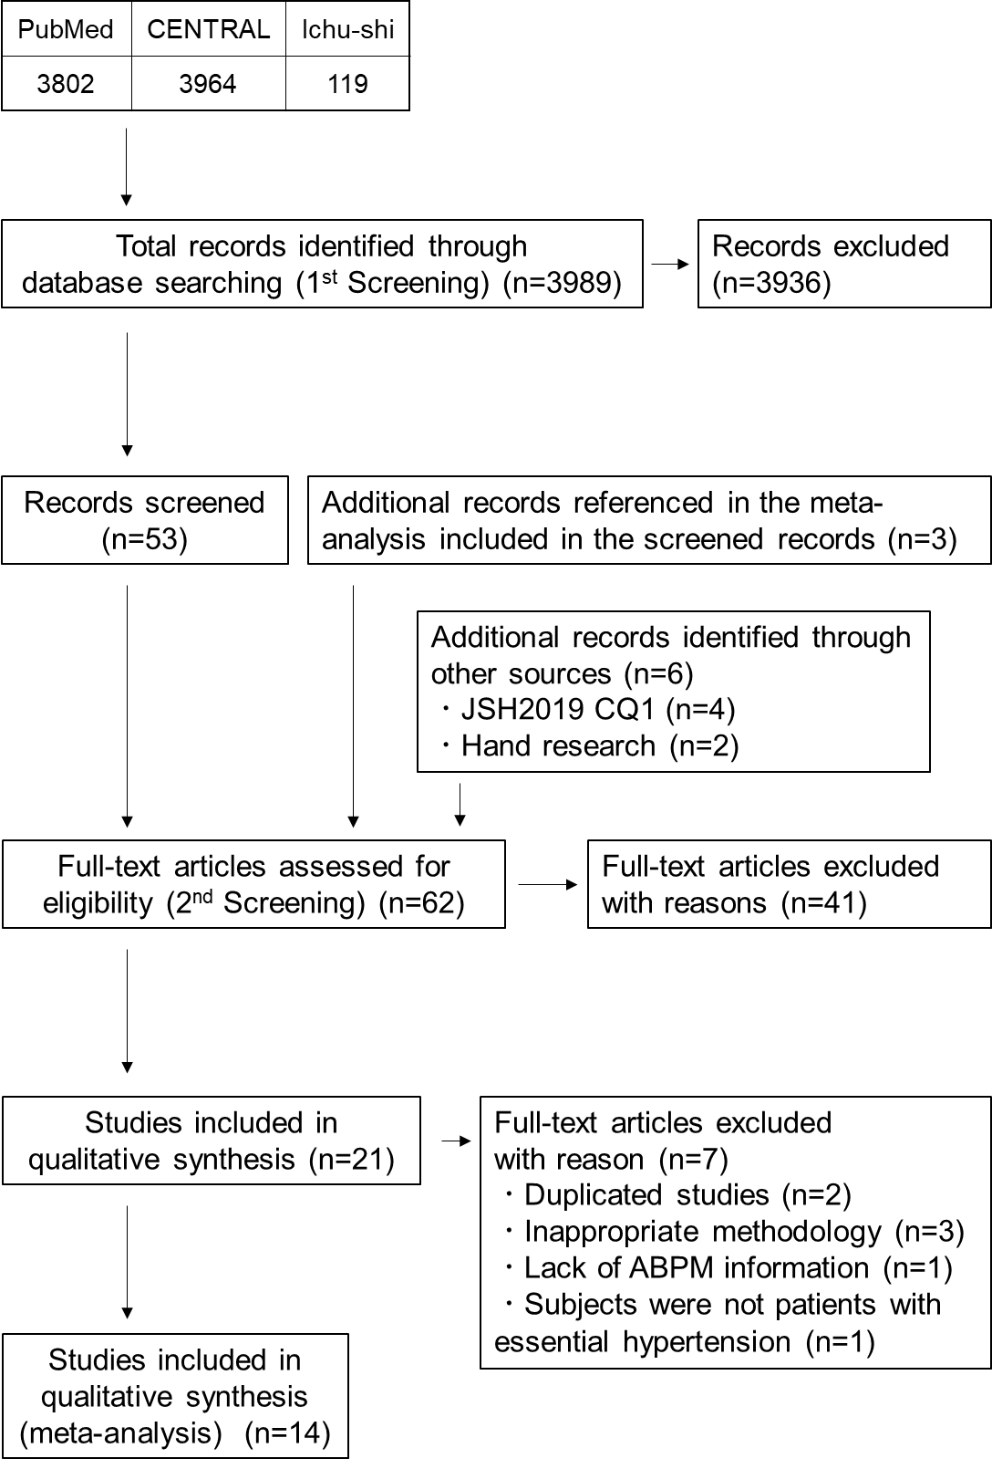

**Supplementary Figure 1.** Flow diagram of the process of selection of the studies to be included in the meta-analysis for BP change outcome.

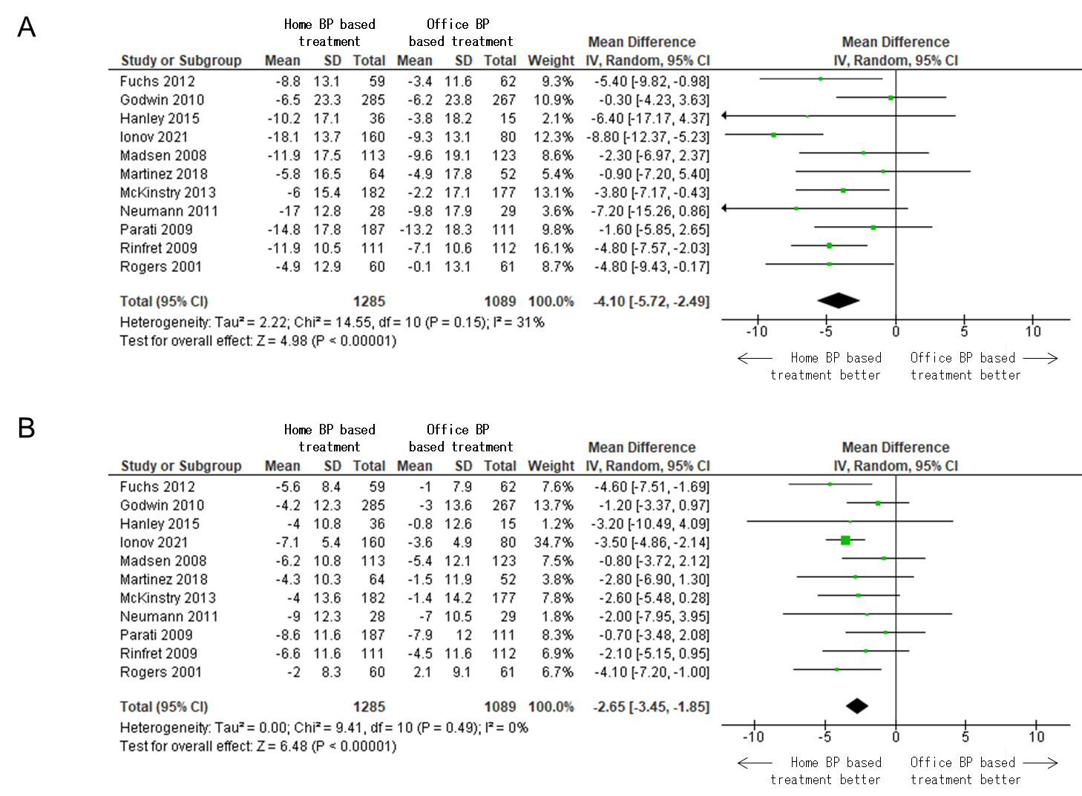

**Supplementary Figure 2.** Home BP-based treatment versus office BP-based treatment for ambulatory systolic BP changes (A) and diastolic BP changes (B) in 11 studies with different blood pressure goals for each treatment arm. We excluded three studies employing the same target BP for both home and office BP treatments.

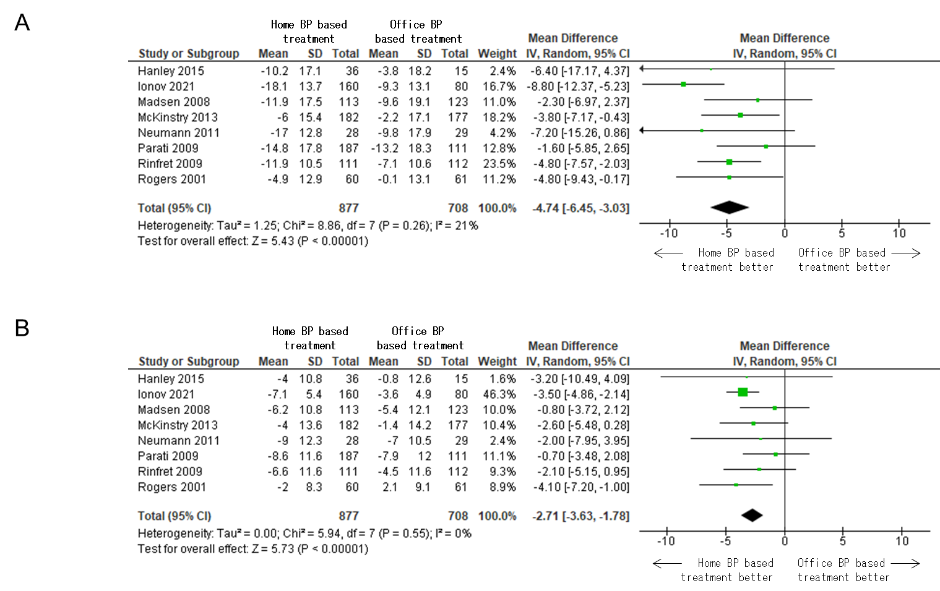

**Supplementary Figure 3.** Home BP-based treatment versus office BP-based treatment for ambulatory systolic BP changes (A) and diastolic BP changes (B) in eight studies that combined telemonitoring techniques with home BP measurements. We included eight studies using telemonitoring for the intervention and a different BP goal for each treatment arm.

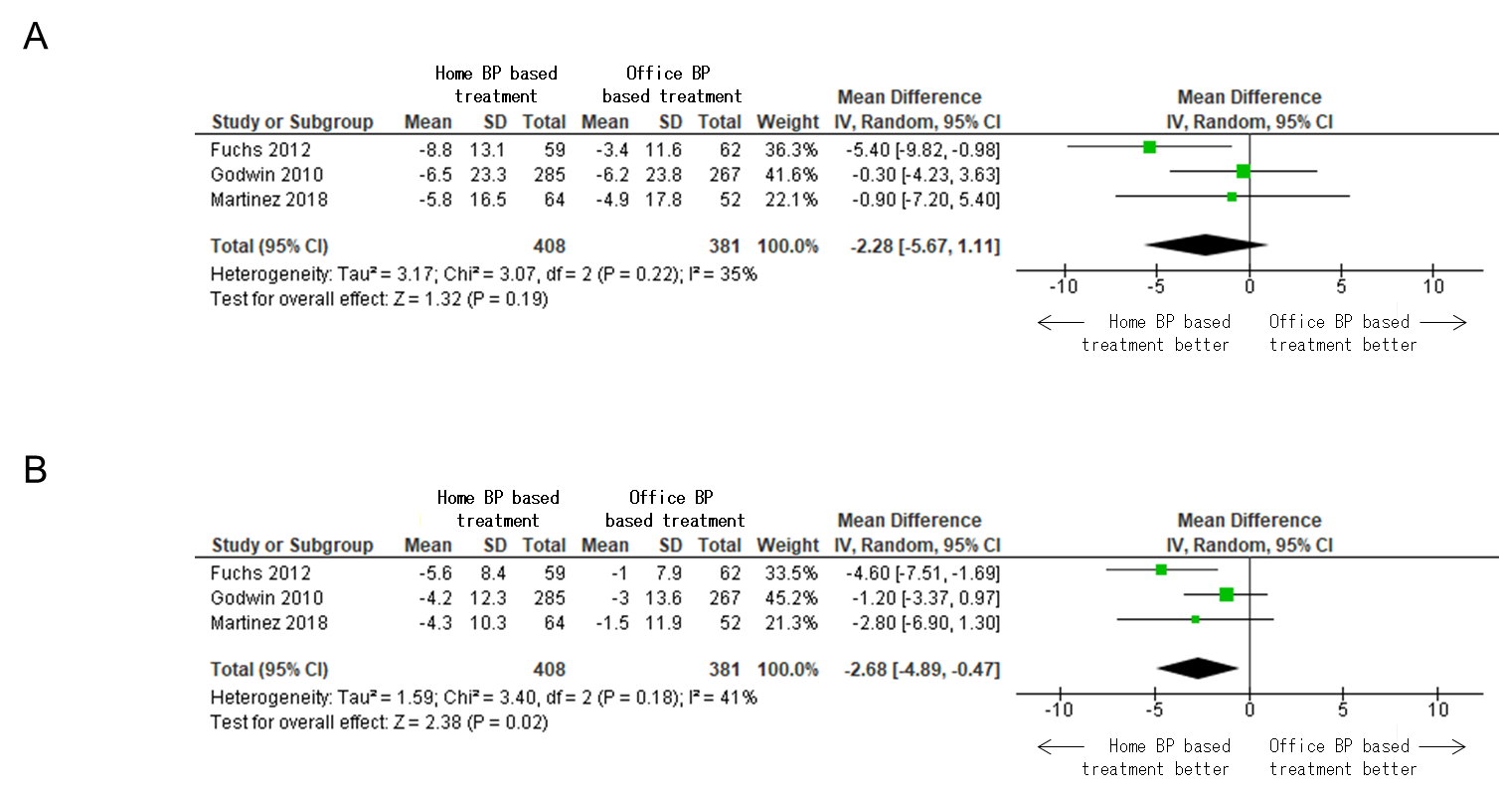

**Supplementary Figure 4.** Home BP-based treatment versus office BP-based treatment for ambulatory systolic BP changes (A) and diastolic BP changes (B) in three studies without combining telemonitoring techniques with home BP measurements. We included three studies that did not use telemonitoring for the intervention and used a different BP goal for each treatment arm.

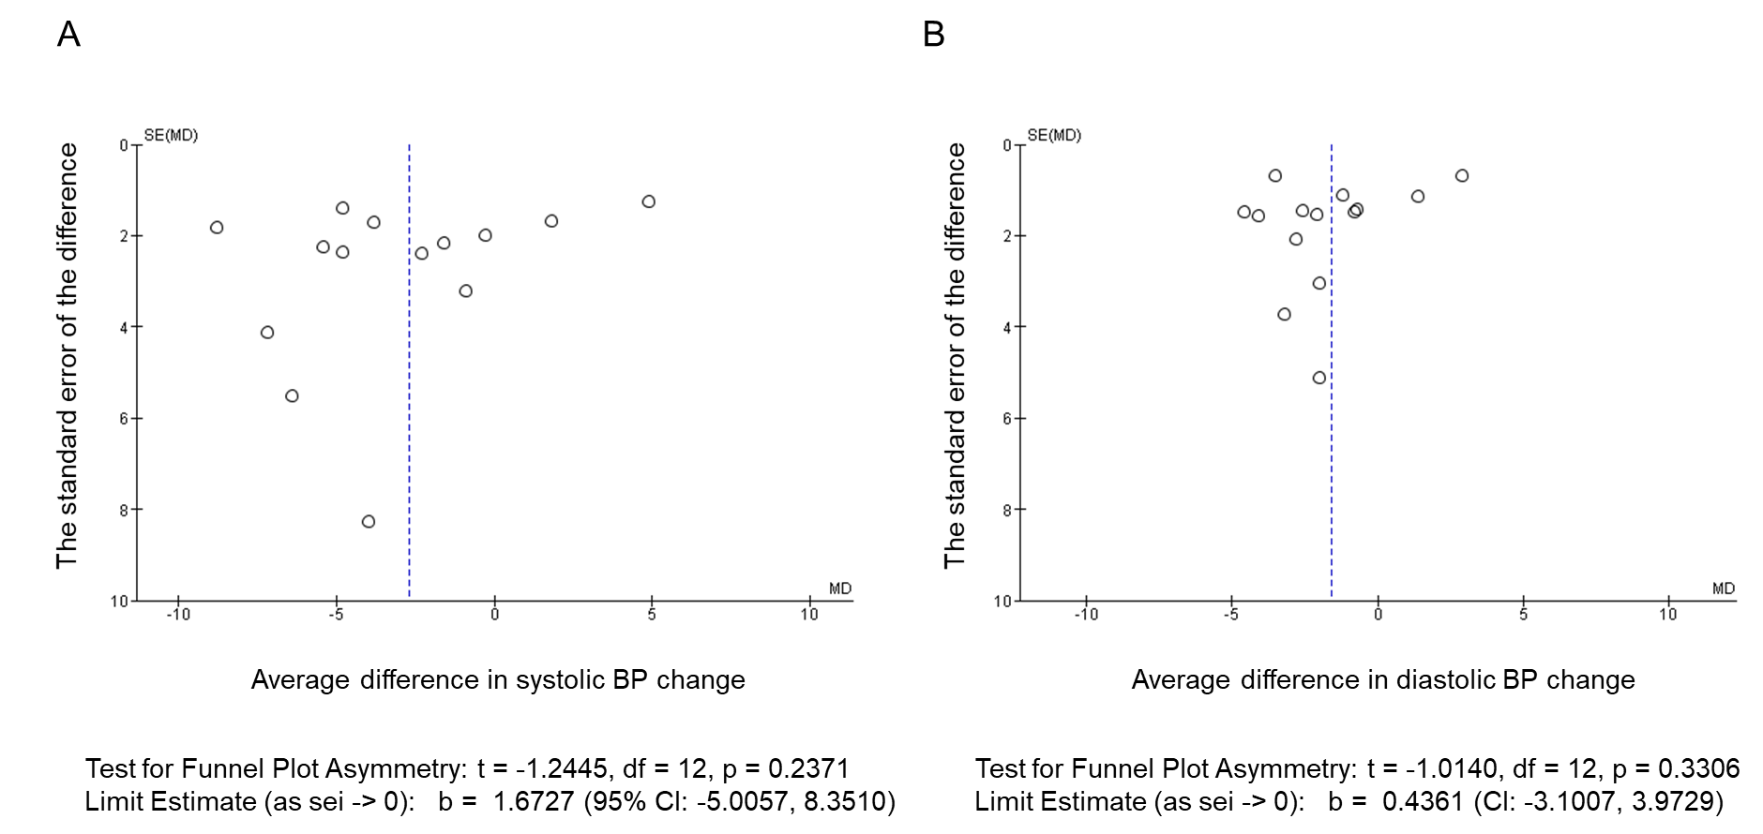

**Supplementary Figure 5.** Funnel plot for the evaluation of publication bias in the meta-analyses for (A) ambulatory systolic BP change and (B) ambulatory diastolic BP change.